NAME …………………………………………..CLASS …………ADM NO…………

INDEX NO. …………….……… CANDIDATE’S SIGNATURE …………..…..………..

451/1
COMPUTER STUDIES
PAPER 1
(THEORY)
TIME: 2 ½ hours

MOKASA ONE FORM FOUR JOINT EVALUATION TEST 2020

Kenya certificate of Secondary Education
451/1
COMPUTER STUDIES
PAPER 1
(THEORY)
MAY 2020
TIME: 2 ½ hours

Instructions to Candidates
- Write your name and index number in the spaces provided above.
- This Paper consists of two sections A and B.
- Answer ALL the questions in section A.
- Answer question 16 (compulsory) and any other THREE questions from section B.
- All answers should be written in the spaces provided.
- This paper consists of 13 printed pages. Candidates should check to ensure that all pages are printed as indicated and no questions are missing

FOR EXAMINER’S USE ONLY
Section | Questions | Candidate’s score
A | - 15
B | 16
 | 17
 | 18
 | 19
 | 20
 | TOTAL SCORE

Section A. Answer all questions in the spaces provided
- Computers evolved through different technological advancement from the first generation to the fifth generation. Differentiate between the 2nd and 3rd generation computers in terms of secondary storage memory, programs and technology used to make them (3 mrks)
……………………………………………………………………………………………………………………………………………………………………………………………………………………………………………………………………………………………………………………
- Explain two situations under which warm booting of a computer may be necessary (2 mrks)
…when the computer hangs
software installation
configurations changes ……………………………………………………………………………………………………………………………………………………………………………………………………
- Repetitive strain Injuries is one of the common problems associated with the use of computers. Explain any two health issues that could arise from improper use of standard furniture while using computers (4marks)
…………………back pains
neck pains ……………………………………………………………………………………………………………………………………………………………………………………………………………………………………………………………………………………………………………………………………………………………………………………………………………
- Differentiate between Control bus and Address bus in computers (2 mrks)
………………………………………………………………………………………………………………………………………………………………………………………………………………………………………………………………………………………………………………………………………………………………………………………………………………………………

- Explain four Data types used in spreadsheets number
………………………………fraction
percentage
currency
number
………………………………………………………………………………………………………………………………………………………………………………………………………………………………………………………………………………………………………………………………………………………………………………………………………………………………………………………………………………………………………………………………………………………………………………
- Utility programs are commonly used to perform some commonly used services to make computing run smoothly. State any two examples of utility programs(2 marks)
………………………………………………………………………………………………………………………………………………………………………………………………………………
- An institution wants to purchase genuine software. Explain any two types of documents that should accompany an original software (2marks)
………………………………………………………………………………………………………………………………………………………………………………………………………………………………………………………………………………………………………………………………………………………………………………………………………………………………
- Kenya National Bureau of statistics has been going through its census using manual systems. State three ways in which computers can be used to improve efficiency in the census process (3marks)
………………………………………………………………………………………………………………………………………………………………………………………………………………………………………………………………………………………………………………………………………………………………………………………………………………………………

- Figure 1 and figure 2 shows icons representing commands used to manipulate graphics in a DTP package.

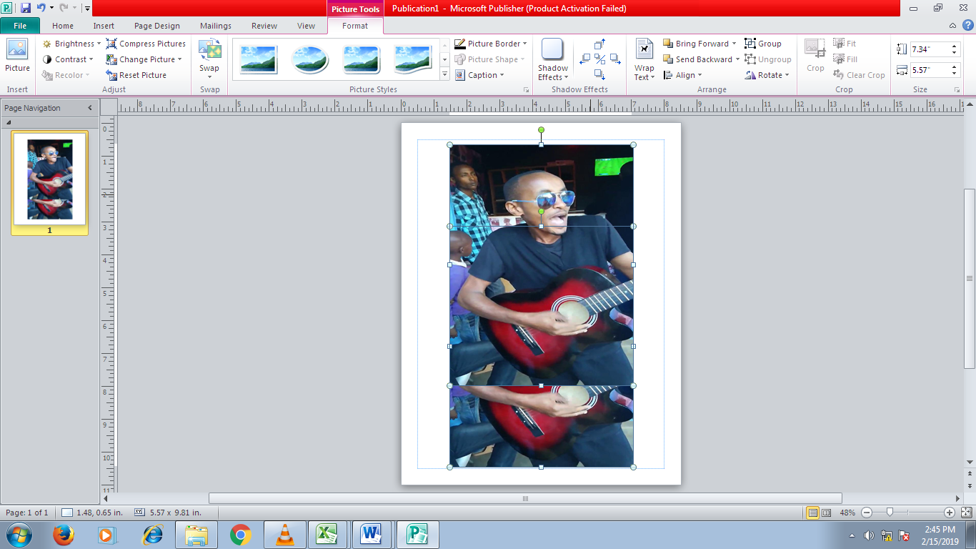
Figure 1
Figure 2

Explain the use of each of the icons labeled Figure 1 and Figure 2 ` (2marks)
…………………………………………………………………………………………………………………………………………………………………………………………………………………………………………………………………………………………………………………………………………………………………………………………………………
- List three paragraph formatting attributes in a word processor (3marks)
………………………………………………………………………………………………………………………………………………………………………………………………………………………………………………………………………………………………………………………………………………………………………………………………………………………………
- A system designer must work well with a programmer to develop a system. State any three duties of a software developer (3marks)
……………………………………………………………………………………………………………………………………………………………………………………………………………………………………………………………………………………………………………………………………………………………………………………………………………………………
- List any four pointing input devices commonly used in computing (2marks)
………………………………………………………………………………………………………………………………………………………………………………………………………………………………………………………………………………………………………………………………………………………………………………………………………………………………

- Differentiate between tracking and kerning as used in DTP (2 mrks)
………………………………………………………………………………………………………………………………………………………………………………………………………………………………………………………………………………………………………………………………………………………………………………………………………………………………
- State four factors that determine how an operating system organizes data in computers (4 marks)
………………………………………………………………………………………………………………………………………………………………………………………………………………………………………………………………………………………………………………………………………………………………………………………………………………………………
- Explain the difference between software portability and hardware portability (2 mrks)
………………………………………………………………………………………………………………………………………………………………………………………………………………………………………………………………………………………………………………………………………………………………………………………………………………………………………………………………………………………………………………………………………………………………………………………………………………………………………………

Section B. Answer question 16 and any other three questions
16. a) define the following terms as applied in programming
i) Syntax (1 mrk)
………………………………………………………………………………………………………………………………………………………………………………………………………………
ii) Source program (1 mrk)
………………………………………………………………………………………………………………………………………………………………………………………………………………
iii) Translator (1 mrk)
………………………………………………………………………………………………………………………………………………………………………………………………………………
b) use the pseudocode to answer the questions that follow
start
set year=1
profit =2
A=10
Repeat
A=A*profit
Year=year+2
Write A
Until year>7
P=A*year
Output P
Stop
- Determine the value of the output P (5 mrks)

- Draw a flowchart for the above pseudocode (7 mrks)

17.a) i) Define the term Artificial intelligence as used in computers (1 mrk)
………………………………………………………………………………………………………………………………………………………………………………………………………………………………………………………………………………………………………………………
ii) List Four categories of Articial intelligence (4 mrks)
………………………………………………………………………………………………………………………………………………………………………………………………………………………………………………………………………………………………………………………………………………………………………………………………………………………………
b) Due to the rapid change in Technology, many campanies are giving up on traditional methods of production. This has affected the companies in many different ways. State any Three benefits that automated methods has affected the industrial production
(3 marks)
………………………………………………………………………………………………………………………………………………………………………………………………………………………………………………………………………………………………………………………………………………………………………………………………………………………………
c) Name Three duties performed by a computer engineer (3 marks)
………………………………………………………………………………………………………………………………………………………………………………………………………………………………………………………………………………………………………………………………………………………………………………………………………………………………
d) With the introduction of computers, it has let to positive or necative impact in the society. State Three Negative effects of ICT on cultural impacts (3 marks)
………………………………………………………………………………………………………………………………………………………………………………………………………………………………………………………………………………………………………………………………………………………………………………………………………………………………

18 (a) Differentiate between a nibble and byte (2marks)
……………………………………………………………………………………………………...
……………………………………………………………………………………………………...
……………………………………………………………………………………………………...
……………………………………………………………………………………………………...
(b) Convert each of the following numbers into their respective equivalence
- 110.101₂ into its decimal (2marks)
……………………………………………………………………………………………………...
……………………………………………………………………………………………………...
……………………………………………………………………………………………………...
…………………………………………………………………………………………………………………...………………………………………………………………………………………...
……………………………………………………………………………………………...
……………………………………………………………………………………………………...
……………………………………………………………………………………………………...
- 734₈ to hexadecimal equivalence (2marks)
……………………………………………………………………………………………………...
……………………………………………………………………………………………………...
……………………………………………………………………………………………………...
……………………………………………………………………………………………………...

- 142.8₈ to decimal equivalence (2marks)
……………………………………………………………………………………………………...
……………………………………………………………………………………………………...
……………………………………………………………………………………………………...
…………………………………………………………………………………………………………………...………………………………………………………………………………………...
……………………………………………………………………………………………………...
……………………………………………………………………………………………………...
……………………………………………………………………………………………………...

- Perform the following arithmetic calculation (2marks)
111.01+1011.111-101.011
……………………………………………………………………………………………………...
……………………………………………………………………………………………………...
……………………………………………………………………………………………………...
…………………………………………………………………………………………………………………...………………………………………………………………………………………...
……………………………………………………………………………………………………...
……………………………………………………………………………………………………...
……………………………………………………………………………………………………...
- Using two’s complement, show how the arithmetic below could be carried out on a 8-bit notation computer system (5marks)
29₁₀ - 54₁₀
…………………………………………………………………………………………………...
…………………………………………………………………………………………………...
…………………………………………………………………………………………………...
…………………………………………………………………………………………………………………...……………………………………………………………………………………...
……………………………………………………………………………………………………...
…………………………………………………………………………………………………...
……………………………………………………………………………………………………...
……………………………………………………………………………………………………...
……………………………………………………………………………………………………...
……………………………………………………………………………………………………...

(a) Differentiate between server and client as used in networking. (2 marks)

……………………………………………………………………………………………………...
…………………………………………………………………………………………………...
…………………………………………………………………………………………………...
……………………………………………………………………………………………………...

(b) The diagram below illustrates satellite transmission media. Name the parts labelled A, B and C.
(3 marks)
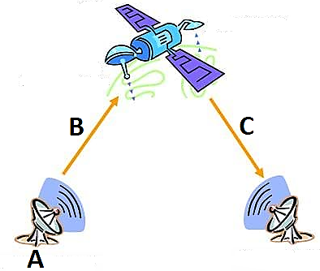

……………………………………………………………………………………………………...
……………………………………………………………………………………………………...
……………………………………………………………………………………………………...
(c) Repeaters are networking devices utilized in data transmission. State two functions of the device. (2 marks)
……………………………………………………………………………………………………...
……………………………………………………………………………………………………...
……………………………………………………………………………………………………...
……………………………………………………………………………………………………...
(d) (i) Define the term network protocol. (1 mark)
……………………………………………………………………………………………………...
……………………………………………………………………………………………………...
……………………………………………………………………………………………………...
(ii) State three benefits of internet to a school. (3 marks)
……………………………………………………………………………………………………...
…………………………………………………………………………………………………...
……………………………………………………………………………………………………...
…………………………………………………………………………………………………...
(iii) Explain the difference between CC and BCC as used in e-mail.(2 marks)
……………………………………………………………………………………………………...
……………………………………………………………………………………………………...
……………………………………………………………………………………………………...
……………………………………………………………………………………………………...
(iv) Apart from passwords, list any four security control measures used to prevent unauthorized access to information systems. (2 marks)

…………………………………………………………………………………………………...
……………………………………………………………………………………………………...
……………………………………………………………………………………………………...
……………………………………………………………………………………………………...
20.a) i) Differentiate between perfective and corrective system maintenance (2 mrks)
………………………………………………………………………………………………………………………………………………………………………………………………………………………………………………………………………………………………………………………………………………………………………………………………………………………………
ii) State three factors to consider when performing file conversion during system implementation (3 mrks)
………………………………………………………………………………………………………………………………………………………………………………………………………………………………………………………………………………………………………………………………………………………………………………………………………………………………
b) i) Define the term data integrity (1 mrk)
………………………………………………………………………………………………………………………………………………………………………………………………………………
ii) Explain any two ways in which data integrity is measured (4 mrks)
………………………………………………………………………………………………………………………………………………………………………………………………………………………………………………………………………………………………………………………………………………………………………………………………………………………………………………………………………………………………………………………………………

c) Operating system consists of a set of complex programs that work together to control execution of user programs and acts as an interface between applications and computer hardware.
i) With reference to disk management system, describe the following operations
a) Disk partitioning (1 mrk)
………………………………………………………………………………………………………………………………………………………………………………………………………………
b) Disk defragmentation (1 mrk)
………………………………………………………………………………………………………………………………………………………………………………………………………………
ii) Give three details about a file that is stored by an operating system (3 mrks)
………………………………………………………………………………………………………………………………………………………………………………………………………………………………………………………………………………………………………………………………………………………………………………………………………………………………

